- WIDE LOAD and superload ACCOMMODATION [618] (revised 12-7-23 M)
Coordinate with the Project Manager to accommodate wide loads and superloads during construction.
Wide Loads. Provide passage of loads greater than 12-feet wide through the project area at least 5 consecutive days/ week and two hours/day. Wide load passage must begin no earlier than 9 P.M. and be completed by 6 A.M. Coordinate with the Project Manager to facilitate passage of wide loads on other projects on the same route or in proximity.
Place wide load information signs at the following locations or as directed by the Project Manager. Furnish and install signs shown on the following detail, meeting Detailed Drawing 618-01. The Route will specify the route number, Dir will specify the direction of the construction, and Mp will specify the milepost(s) of the work. Remove signs within 24 hours of removing the wideload restriction.

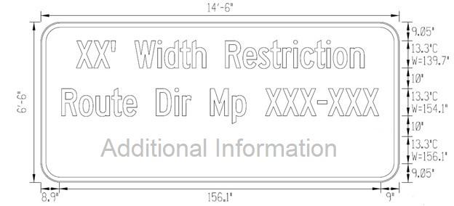

Sign information, if known:
XX’ Width Restriction
I-XX DIR MP XXX -XXX
Additional Information

Sign Location | Location Description
sign location | location description

Superloads. Loads greater than 18’0” wide, 150’0” long, or 17’0” high must contact the Prime Contractor Monday – Friday, 8:00 AM to 5:00 PM, before traveling to make special arrangements to be escorted through the project site on a case-by-case basis. Notify the Project Manager and provide justification before denying carriers access to the project.
Measurement and Payment.
Wide Loads. Traffic control necessary for wide load staging areas including wide load staging signs, staging information signs, arrow boards, lane closures, cameras, and wide load passage/marshaling will be included in the traffic control bid item Wide Load Marshalling -L.S.
Devices damaged by wide load passage will be replaced by the Contractor and paid for in accordance with contract’s Traffic Control Rate Schedule.
Superloads. Traffic control necessary for marshaling superloads that require an escort outside of the contract required marshaling times is paid for by the Department. Pilot cars, flaggers, damaged devices, and Category #2-Adjustments will be paid for in accordance with the contract’s Traffic Control Rate Schedule.
Super Load Administration. A flat fee of $275 will be paid to cover administration cost for each permitted superload that necessitates an escort. The $275 fee will be paid for superloads that require an escort outside of the contract required marshaling times. To receive payment for superload administration provide written documentation to the Project Manager 24 hours prior to the superload’s arrival on project. This fee is paid under Miscellaneous Work.
Wide load information signs will be paid for as Single Use Signs (SQ FT). Cover the signs during the winter suspension if necessary. No separate payment will be made to cover wide load detour signs during winter suspension.

