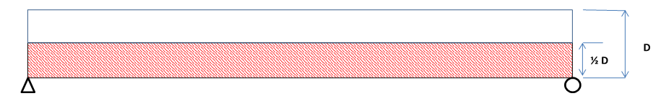
Consider the fracture critical portion of the floor beam as the lower half of the beam depth, the portion below the neutral axis that is in tension. Note any defects and label the defect accordingly. Make sure and note that a defect is Near Face (NF), Far Face (FF) or Both Faces (BF). All notations will be recorded looking ahead on line. Use this drawing for trusses or two girders system bridges with solid rolled or built up section floor beams.

Typical Floor Beam Comments:

Span | Panel Point | Inspection Comment | Photos
i.e. 1 | i.e. L0 | i.e. Broken tie plate on North Truss | i.e. see SMS  Element 152
Span | Panel Point | Inspection Comment | Photos

