- MOTORCYCLE ADVISORY SIGNS [619] (REVISED 7-16-20)
  - Description. This work is the furnishing, installing, maintaining, and removal of motorcycle advisory signs.
  - Materials. Furnish materials meeting the requirements of Subsection 618.02. Furnish ASTM D4956 type VI or higher retro-reflective sheeting.
  - Construction Requirements. Furnish and install the signs shown on the following detail to the required typical cross section and profile grade, meeting Detailed Drawing 618-01, two-post installation, at the locations listed in the contract. The ROUTE will specify the route number and the DIR will specify the direction of the construction. The sign must meet the height requirements specified on the Detailed Drawing.

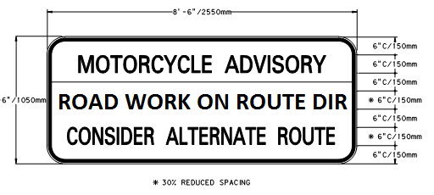
For rural intersections install sign(s) on the right shoulder within 1000 feet to 1500 feet (300 m to 450 m) in advance of the roadway’s intersection. For urban intersections install sign(s) within 200 feet (60 m) of the roadway’s intersection. Adjust sign within the specified distance to prevent obstruction from existing signs.
Install sign(s) no more than 2 calendar days before construction activities begin that change the roadway surface from a paved surface to an unpaved surface. Remove sign(s) within 2 calendar days after the roadway surface has a paved surface.
Coordinate with the Project Manager the date the sign(s) are to be installed, the verification of the sign locations, and the date of removal.
  - Method of Measurement. Motorcycle advisory signs, including all costs associated with labor, materials, tools and equipment required to provide, install and remove are measured by the Each.
  - Basis of Payment. Payment for the completed and accepted quantities is made under the following:

Pay Item | Pay Unit
Motorcycle Advisory Signs | Each

Payment at the contract unit price is full compensation for all resources necessary to complete the item of work under the contract.

