*Add PROJECT NAME, meeting location, date, etc. here.*

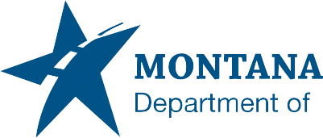

**Community Involvement Survey**

**Completing this survey is voluntary but encouraged.**

You are not required to provide the information requested to participate in this meeting; however, your response will be helpful in ensuring the fairness and equity of MDT’s community involvement process.

All survey responses are anonymous and confidential.

**What is your race?**

Black or African American  American Indian or Alaskan Native  Asian

White  Hispanic or Latino  Native Hawaiian or Other Pacific Islander

I prefer to self-describe:

**What is the primary language spoken in your home?**

English  Spanish  German  Other (Please specify):

**What is your annual household income?**

Less than $10,000  $10,000 - $24,999  $25,000 - $49,999

$50,000 - $74,999  $75,000 - $99,999  $100,000 +

Please suggest additional ways you think MDT can improve our community outreach efforts.

Thank you for completing this survey.